3
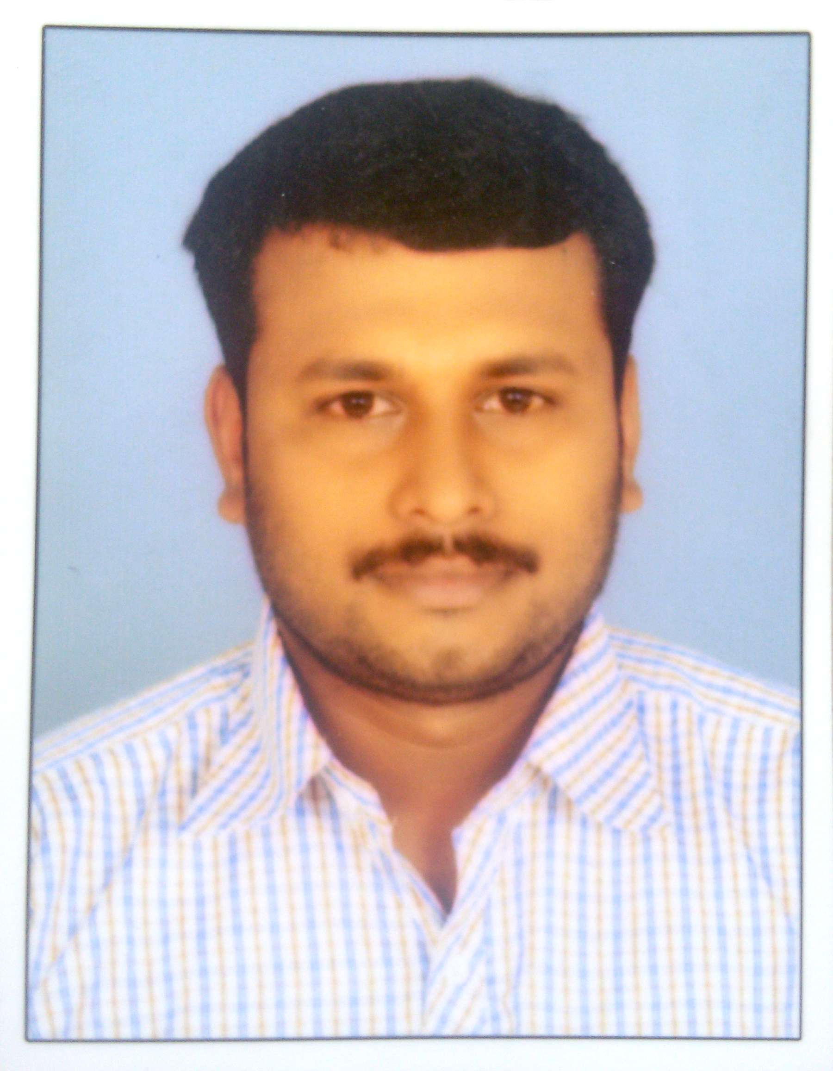
SANEESH V.S

0555773016/+91-9946135616

E mail id: vsaneesh916@gmail.com

Career Objective:

A hardworking individual, who believes on professional ethics, capable of working in a multicultural environment, can adopt easily in any situation, pays attention to details, highly organized, analytic and eagerly accepts any challenging responsibilities.
Skills and Duties:
- Technical documentation and reporting.
- Profession in MS office program such as Word and Excel.
- Constant attention to detail.
- Demonstrated leadership skill.
- Can build strong interpersonal relationship.
- Comprehensive knowledge of test instrumentation measurement techniques and metrology methods.
- Having an analytical mind.
- Ability to problem solve in a logical way.
- Excellent punctuality and attendance record.
- Developing, testing and make modifications to mechanical equipment.
- Assisting with mechanical installation.
- Explaining technical issues to non technical people.
- Repairing or replacing defective equipment parts.
- Interpreting test plans and procedures.
- Wearing appropriate safety clothes in designated safety areas.
- Keeping the work place in an organised and clean condition.
- Cleaning and lubricating gears, shafts, bearings and other machinery parts

Educational Qualification
- SSLC
- PLUS TWO
- DIPLOMA ( MARINE MECHANICAL ENGINEERING)
Work Experience
Company | Designation | Periods
UNIVERSAL ENGINEERS, GOA | ASST.FITTER | JUNE 2007 TO JULY 2008
PREMIER MARINE  ENGINEERS,DUBAI | MECHANIC | JANUARY 2009 TO SEPTEMBER 2009
ARCHIRODON MARINE CONSTUCTION,DUBAI | MARINE TECHNITION | 2012 TO CONTINUING

- Personal Profile
Father’s Name: | Mr.SHANMUGHAN.V.K
Communication Address: | SANEESH.V.S  VENKALATH HOUSE,  THIRUVATHRA P.O  PIN-680516  CHAVAKKAD, THRISSUR  KERALA,INDIA
Date of Birth: | 20-02-1986
Mother Tongue | Malayalam
Language known: | - English  - Hindi  - Malayalam  - Tamil
Native Place | Thiruvathra, Kerala
Passport details  Passport No.  Place of issue  Date of issue  Date of expiry | - R9740850  - Cochin  - 23-02-2018  - 22-02-2028

Declaration
I hereby declare that the above given information are true to the best of my knowledge and belief.
On the basis of the above I hope that you will give me a chance in your esteemed firm to prove my abilities to the superiors with full of satisfaction and sincerity.

Saneesh v s

