Resume

Electrical technician r industrial Electrician

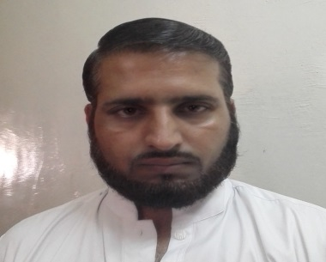

MUHAMMAD RAFIQ
Mobile: +92303 4195 328
m.rafiq21@yahoo.com

Objective:

Looking forward to work in stimulating and challenging environment that could conclude my potential into performance and recognition for hard work, honesty and sincerity, thereby contribution to the growth of the organization and me

Date of Birth : 01 Aug, 1980
Nationality : Pakistani
Languages : English, Urdu .Arabic
Marital Status : Married
Religion : Muslim

Current Location : pakistan

Educational Qualifications:

Khyber pakhtunkhwa board of technical education Peshawar Pakistan diploma of dae (Electrical)

- HSE – Science Sargodha Board

Summarized Professional Experience (Abroad)

Jan, 2015 to Present (Electrical Technician)
Energy Resources Development Company Ltd
Saudi Electric Company Saraura

Duty & Responsibilities:

- Electrical Maintenance.
- Taking care of all Electrical equipments & Troubleshooting
- Experienced in Instrument and power cable termination.
- Planning the execution of all electrical works and co-ordinates with the Mechanical and Civil groups.
- Assign targets for accomplishments and ensure targets are met on daily basis as advised by my foreman.
January 2015 till…. Electrical technician till now Saudi Electricity company
Aug, 2006 to Jun, 2014(Industrial Electrician)
Metals Services for Trading & Contracting Company
- Jan, 2014 to till Jun, 2014
Aramco onshore oil and gas well projects, Hawiyah
- Mar,2012 to Dec,2013
Sales Gas Delivery System to Riyadh PP 11 at Dhurma
- May,2010 to Feb,2012
Gas Distribution Network Royal Commission Yanbu
- Jan,2009 to Apr,2010
Saudi Aramco Petro Chemical Plant Rabiqh
- Oct,2008 to Dec,2008
Saudi Aramco Downstream pipeline projects Khurais
- Aug, 2007 to Nov,2008
Sulphur plant – PetroRabigh.
- Aug,2006 to Jul,2007
Saudi Aramco Bulk Plant AL QasimBuraydah

Duty& Responsibilities:

- Experienced in Instrument and power cable termination.
- Planning the execution of all electrical works and co-ordinates with the Mechanical and Civil groups.
- Assign targets for accomplishments and ensure targets are met on daily basis as advised by my foreman.
- Ensures that all the works done are in accordance with the approved construction drawings, contract documents, project specifications, and all applicable standards.
- Assembling, Installing, Testing and Commissioning.
- Splicing and Termination of MV Power Cables up to 15 KV

Summary of Duties Performance:

I have worked in different Project with different jobs. All Electrical works related SAUDI ARAMCOEngineering Standard (SAES) and SAUDI ARAMCO Engineering Procedure (SAEP). I got many Experiences in my work field specially OIL & GAS Field, Hazards and Non Hazards location works, Pipeline Crossing area , Valve Station , Metering Station Boosting Pump Stations, Upstream projects(GAS WELL HEADS) and Bulk Plants. Also working with Saudi Electricity company Sharora power plant maintenance department

Declaration:

I here by declare that all the information mentioned above is true to the best of my knowledge and belief.

Date: 05/23/2017 Name:Muhammad Rafique Signature:

