Marek Labeda
Hilli Complex, Building 48, Apartment 12.
Al Ain – UAE.
Phone: +971 50 795 1807
E-MAIL: mlabeda@gmail.com

NAME: MAREK LABEDA
DATE OF BIRTH: 22 MARCH 1992
PASSPORT #: A01343484
DRIVING LICENSE: RSA, UAE, INTERNATIONAL
NATIONALITY: SOUTH ARICAN
MARITAL STATUS: MARRIED
LANGUAGES: ENGLISH, POLISH & AFRIKAANS

Accreditation and Work Experience

REPUBLIC OF SOUTH AFRICA ACCREDITED:

2010-2017
Millwright (Electro Mechanical Technician) – External trade test
QCTO – Quality council for trades and occupations
Trade Code: 671 202
Red Seal: 12/89 522
-
SUMMARY OF PROFESSIONAL EXPERIENCES
- Electro Mechanical Technician with Sasol and Arcelor Mittal

- Supervisor;
- Roles included:
- Senior staff trainer, instructing incoming staff on policy and procedures.
- Senior supervisor in Boilermaker
- Excellent Team Player
- Initiative, cognitive and constructive thinking
- Motor, machinery and vehicle maintenance and repairs
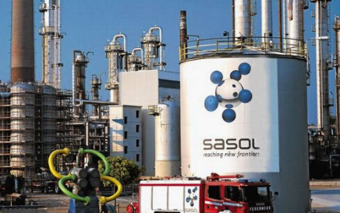
SASOL
OIL & GAS EXPLORATION
Sasolburg
Free-State,
SOUTH-AFRICA

Senior Supervisor.
Training-Electro Mechanic (Full time & Trade Testing)

Description of Work:

- Motor replacements
- Motor alignment
- Electrical Maintenance of shuttle cars
- Continuous miner machine maintenance
- Conveyor belt joining on site
- Incident report and feedback to subordinates
- Welding and grinding
- Crane and tipper repairs and Maintenance
- General plant assistance and upkeep
- Preventative maintenance
- Maintenance inspections
- Mechanical breakdowns
- Hydraulics
- Pneumatics
- Conveyors
- Stacks
- Furnace
- Tipplers
- High tension Systems
- Over-head cranes
- Screens
- Ms Word knowledge and skills
- Fault finding

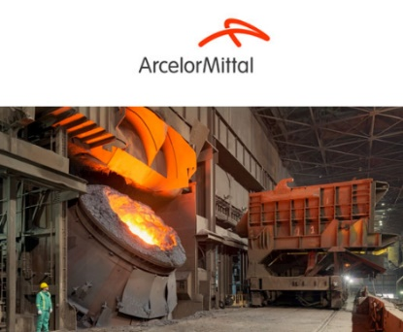
ARCELOR MITTAL
Vanderbiljpark
Gauteng,
SOUTH-AFRICA

Supervisor
Roles included:

Electro Mechanical Technician
Boilermaker,

Description of Work:

- Motor replacements
- Motor alignment
- Conveyor belt joining on site
- Welding and grinding
- Crane and tipper repairs and Maintenance
- General plant assistance and upkeep
- Preventative maintenance
- Maintenance inspections
- Mechanical breakdowns
- Hydraulics
- Pneumatics
- Conveyors
- Stacks
- Furnace
- Tipplers
- High tension Systems
- Over-head cranes
- Screens
- Ms Word knowledge and skills

REFERENCES:
SASOL OIL & GAS EXPLORATION ARCELOR MITTAL
Johan vd Merwe / Thomas Seekoei /
Tony Syrzysko Adam Łabęda
Foreman and Production Manager Foreman
Sinther plant
+27832937991 +27823575016

