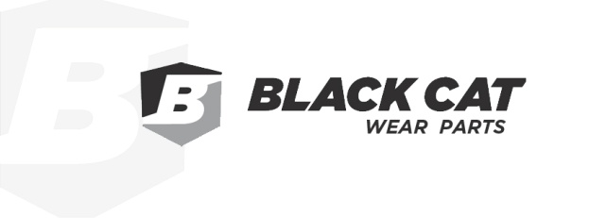

Are you looking for an employer who makes safety a priority and is an industry leader in safe work practices? Is a career in a quality driven environment important to you? Does unique work that provides an opportunity for skill development motivate you? If you’ve answered yes to these questions, then Black Cat Wear Parts, one of Canada’s Best Managed Companies for 2023 is looking to team up with you!
Black Cat Wear Parts is an ISO certified manufacturer and international supplier of quality ground engaging tools for the construction, mining and road maintenance industries.
Black Cat Wear Parts Ltd. is an ISO Certified manufacturer and international supplier of quality ground engaging tools for construction, mining and road maintenance industries. Our quest is to be the supplier of choice by offering the best quality and the best customer service while striving for the lowest production costs. We aim to be an employer of choice by providing a safe, harmonious, stimulating, team driven workplace whereby people have the opportunity to grow.
We are currently seeking a Journeyman Industrial Millwright or 4th level apprentice to work in our MADE SAFE Certified plant. Experience in the steel industry, steel processing and industrial automation would be considered an asset. This position will be working closely with our production team while maintaining and enhancing our equipment and facilities.
Qualifications of a suitable candidate are:
- A valid Red Seal Industrial Mechanic (Millwright) certificate, or proof of apprenticeship
- A strong aptitude for safe work practices
- An outstanding ability to work successfully as part of a multi-disciplined team of tradesmen
- A willingness to support our Millwright Apprenticeship Program
- Familiarity with Preventive Maintenance and Total Productive Maintenance programs
- Experience with CNC equipment, drilling, punching and heat treating operations
- Ability to troubleshoot automated systems
- Good fabrication skills
- Excellent interpersonal and communication skills

Salary ranges up to $39.13 per hour plus premiums, depending on experience. Successful applicants will be required to work shifts to support our 24/5 operations.
Black Cat Wear Parts Ltd. offers a comprehensive benefits package. To learn more about Black Cat Wear Parts Ltd. visit our website at www.blackcatwearparts.com.If you have these qualifications and background, please submit your resume here.
We would like to thank all who apply, however, only those selected for an interview will be contacted.
Please note that interested and qualified candidates will be asked to complete off-site pre-employment testing through a registered facility.
