Heavy Duty Mechanic $38-$46/hr THE PARKWAY CREW Repair and Towing (North Van/Seymour)
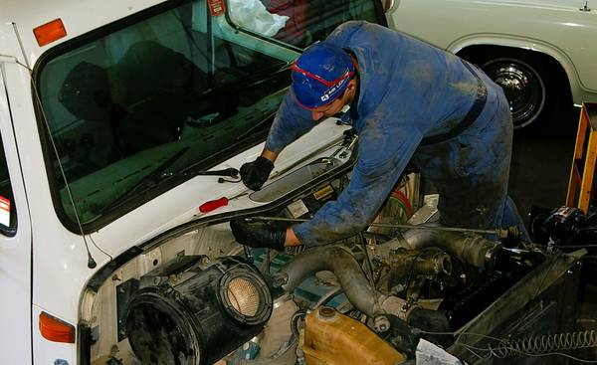
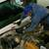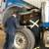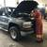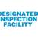
compensation: hourly wage 38.00 - 46.00
employment type: full-time
job title: Heavy Duty Mechanic
WE NEED ANOTHER MECHANIC! Certified Automotive or HD Mechanic wanted in busy North Vancouver repair shop. Wage based on experience & skill level.
Our Business is Full Service Repair and Towing on the North Shore for over 25 years serving our customers and commercial fleet clients in the Vancouver area.
Who are we hiring for?
• Certified Automotive Service Technician, HD Mechanic or Commercial Transport Mechanic
• Area of Specialization: all makes, diagnostics, diesel, alignment, steering and suspension, brake systems, fuel and emission systems, ignition and electrical systems, AC, cooling and heating systems and truck-trailer repair.
Requirements:
• Possess an Automotive Service Technician Trade Certification, Motor Vehicle Inspector Certificate and valid driver's license.
• Must be capable of servicing and operating all types of vehicles
We Offer:
- Flexible work environment and opportunity for growth in the company
- Competitive wages with starting rates based on experience and certificate level
- Excellent benefits including medical, dental and paid vacation
- Signing bonus, and additional perks
- 3 weeks vacation
Related Job Title:
Automotive Technician, Automobile Mechanic, Heavy Duty Commercial Transport Mechanic, Diesel Mechanic
If you feel that you possess the knowledge, skills and abilities mentioned above then we would love to hear from you!

