Vantage Airport Group has operated North Peace Regional Airport since 1997. Located in the Peace River region of BC in Fort St. John, the airport is growing steadily, welcoming over 252,000 passengers in 2017. More information: www.fsjairport.com.

Airport Technician 3 (APT3)
(Red Seal Electrician)

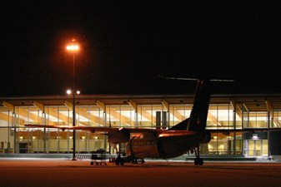

The APT3 (Electrician) is part of the maintenance and Aircraft Rescue and Firefighting (ARFF) team, which is responsible for ensuring the safe and efficient operation of North Peace Regional Airport. This role performs electrical servicing on facilities and equipment, as well as participating in regular maintenance activities. This role works on a rotational shift basis to cover the airport’s 24/7 operation. The hourly rate is $39.98. Please note: The successful candidate must provide proof of fully vaccinated status prior to commencing employment.
Reporting to the Manager, Airport Operations & Emergency Services, the APT3 (Electrician) is responsible for
- Providing electrical servicing for facilities and equipment through scheduled inspections and as needed to ensure availability of airport services and facilities
- Performing maintenance functions on facilities and equipment through scheduled inspections and as needed to ensure availability of airport services and facilities
- Successfully completing training specified in the aircraft fire-fighting standard (CARs 303, 323)
- Operating various pieces of mobile equipment, including heavy machinery
- Participating fully in the emergency response program for the airport as an active team member
- Consistently complying with workplace health and safety practices

Qualifications Required

- Minimum 5 year’s work experience in an airport operating, facilities maintenance or industrial environment
- Red Seal Electrical ticket required; experience in airport electrical operations a strong asset
- A valid Class 3 driver’s permit with airbrake endorsement
- Knowledge of and experience with emergency response procedures
- Knowledge of and experience with facilities and equipment preventative maintenance
- Knowledge of summer/winter pavement and turf maintenance an asset
- Secondary school certificate or equivalent, and effective verbal and written communication skills
- A restricted radio operator’s license, airside vehicle operator’s permit, and a PAL (possession & acquisitions licence) and CORE (conservation outdoor recreation education), or ability to obtain same

This position is open to external candidates. Previous relevant job performance will be taken into consideration for all applicants.
Applicants
Go to the Careers page of Vantage Airport Group, and follow prompts to apply with your cover letter and résumé
by Monday, November 29 at 5.00 pm Pacific Time

Vantage Airport Group is an industry-leading investor, developer and manager of airports whose global
network encompasses a diverse group of assets, including airports in Canada, Europe, the Caribbean and the United States.
More information: www.vantageairportgroup.com

