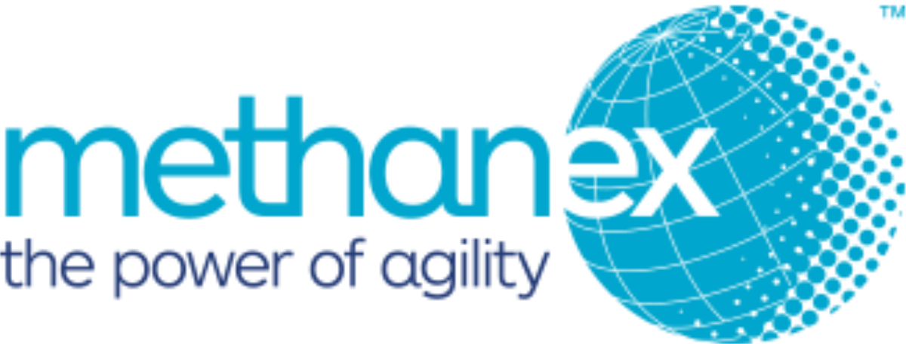

Rotating Equipment Supervisor

Job No: 116672

Location: Medicine Hat, Alberta
- Bring your leadership experience to a rewarding role!
- Put your expertise to work in a dynamic role within a collaborative team environment!
- Receive competitive compensation and benefits with a global leader!

ABOUT THE ORGANIZATION
Methanex is the world's largest supplier of methanol to major international markets in North America, Asia-Pacific, Europe and Latin America. Methanol can be found in products from windshield washer fluid to recyclable plastic bottles, plywood floors to paint, silicone sealants to synthetic fibers. The energy sector is one of the most rapidly growing markets for the use of Methanol and greatly relies on the expertise and commitment of Methanex as their trusted supplier.
With the care of the environment as the root of their business, Methanex is a Responsible Care® company committed to the safe, ethical and environmentally sound management of the chemicals it makes and uses. Responsible Care® is an ethic established by the Chemical Industry Association of Canada (CIAC). The Responsible Care® ethic is an integral part of Methanex’s global commitment to ensuring the well-being of all stakeholders, wherever Methanex does business.

ABOUT THE OPPORTUNITY
Methanex is currently seeking a Rotating Equipment Supervisor to join their team in Medicine Hat, AB on a full-time basis.
As the Rotating Equipment Supervisor, you will be responsible for ensuring that the plant operating systems are maintained safely and efficiently, fostering a strong safety-based attitude in everyday activities, and working within outlined budgets. You will also be responsible for ensuring that direct reports are trained and competent.
More specifically your responsibilities in this role will include:
- Coordinating prompt, safe, and quality repairs to process equipment through accurate scheduling and time management.
- Continually assessing methods to improve site performance such as cost-saving, site safety, and plant reliability.
- Ensuring that Work Safety Controls System and site policies and procedures are followed and maintained.
- Managing, inputting, and investigating Incident Management System (IMS) incidents.
- Leading the department during turnarounds and outages.
- Actively participating in developing, forecasting, maintaining, and working within the maintenance operating budget.
- Ensuring compliance with all Pressure Equipment Management (PEIM) responsibilities as per the PEIM manual.
- Directly supervising workers to ensure work is completed safely and to a high level of quality while also meeting scheduling demands.
- Participating in the recruitment and selection of new employees within the Rotating Equipment team and Maintenance team.
- Initiating direct reports yearly performance reviews and sets goals for the outlined year.
In order to qualify for this role, you will have at least 5 years of relevant industry leadership experience along with a journeyman millwright trade certification, individuals that are qualified in a related field with relevant experience may also be considered. You will also need a valid driver's license and at least 5 years of plant maintenance experience.
As our ideal candidate, you will also have knowledge of maintenance techniques such as laser alignment, vibration analysis, and oil analysis as well as previous experience with a computerized maintenance management system (CMMS). Your technical knowledge will combine with your strong communication, organizational, and leadership skills to ensure your success in this role.
Finally, you will be results-driven and improvement focused with a demonstrated history of developing a team in order to achieve your goals.
If you have the drive, determination, and ambition to meet and exceed expectations, then we invite you to apply today!

ABOUT THE BENEFITS
Building on our core values of integrity, trust, respect and professionalism, our corporate culture encourages communication and teamwork and rewards employees for creativity and innovation. We are also very active in supporting educational and training/development initiatives. We sponsor scholarships and co-op programs at local colleges and universities as well as hands-on training programs at our manufacturing facilities.
In exchange for your hard work and dedication, you can expect to receive an industry competitive salary.
Join this thriving and team focused market leader today and expand your experience with a new challenge - Apply Now!

