January 2025

Dear Fellow Owners,

We hope you all enjoyed a wonderful holiday season, and welcome to 2025! Two years of major renovations to our units have nearly wrapped up. The Management Company recently provided a progress report on the punch lists of final fixes.

Together with recent renovations and improvements in the common areas such as the lobby, our property is looking great. For those in the rental pool, this already has been boosting average daily room rates. Rack rates have been increased again for 2025, and we continue to see little discounting.

2024 Financial Performance

Operating performance for the year 2024 was in a shortfall position of approximately
$10,000 or 0.5% of Strata Revenues of just more than $2 million. The Capital Expenditures (Capex) budget was also in a shortfall position, of approximately $74,000.

Unfortunately, the 25% Capex rate increase assessed in 2024 did not meet
planned and unexpected Capex projects. Some of the unexpected Capex items
included: replacing the HVAC unit associated with the gym and surrounding Strata
common areas under Building 1; painting all unit entrance doors which in the past was a
separate unit owner charge; replacing the fire panel in Building 4; refurbishing chlorine
feeders to the pools; replacing patio frames above and beyond what was planned (as
materials and labor were readily available to further complete this improvement in 2024); and additional new beach lounge chairs, upright chairs and cushions for many of the pool lounge chairs.

2025 Operating Budget

We have approved the Operating Budget for 2025. Strata fees will increase 5%. The biggest contributor to the required increase continues to be payroll costs. Wage rates are expected to rise almost 5%, and benefit costs continue to grow at an even faster rate. We also expect to fill two positions that were vacant in 2024 (plumbing and A/C).

Capital Fund Budget

As your Executive Committee, we have been focused on the need to address our property’s aging infrastructure. We completed an engineering review by a company known as BCQS, and its report is being posted to the Owner Website. This report shows each property item that at some point will require repair or replacement, and the estimated year in which each of those costs should be expected.

Neither the exact amounts or timing or repairs or replacement are written in stone. Spending will depend on actual wear and tear and costs at the time of needed replacement.

Some Capex items are fairly steady and are already included in the annual budget. For
example, painting the exterior of all buildings is a large on-going annual item. Entrance
doors and patio frames are replaced as they wear out.

Other items, however, may occur in one-time large dollar amounts. The 2025 year, for
instance, includes re-tiling the entire third floor landing of Building 3 at an expected cost
of $85,000. An upgrade to the Bionest system and an elevator overhaul may be
expected in the 2027/28 timeframe. Replacing the tile roofs is expected to cost more than $1 million between 2029 and 2034.

Items that need replacement or repair on a regular basis will continue to be charged to
the Capex budget. Our experience over the past two years, along with the items
identified within the report issued by BCQS and estimates of future needs, require an increase in the 2025 Capex assessment by 25%.

Long-Term Major Reserve Fund

The Long-Term Major Reserve Fund, as of the close of 2024, had a balance of approximately $750,000. The initial goal of this fund was to achieve a balance of no less than $500,000 in order to cover the insurance deductible in the event of an unexpected major-disaster, such as a Hurricane Irma. Since the balance of this fund has exceeded the goal of $500,000, we intend on using this fund to pay for major life-cycle Capex items identified in the BCQS report.

Therefore, Strata will continue to maintain and fund this balance. There will be no change to the Major Reserve assessment for 2025.

For 2025, the Long-Term Major Reserve Fund will be used to pay for Building 3 landing
Tilework. It also will absorb the Capex deficit from 2024 of approximately $74,000.

Audit

Further to the discussion at the last Annual General Meeting, we proceeded with a limited form of audit known as an “Agreed Upon Procedures” review. We hired a local firm, WB Financial Group, to perform this review.

While the study showed no major issues, it did highlight some discrepancies, notably in inventory valuation, that are being addressed. The review summary is being posted on the Owner Website. Please read it at your leisure and send any questions to Tom Mothorpe, at tmothorpe@gmail.com.

TV Service

The new Hospitality Grade IPTVs now have been installed in most units. The final wiring to bring fiber-optic cable to each TV outlet is underway and will continue room by room through the winter as vacancies permit. So far, there have been no issues with pulling the new cable through the existing wall channels, and each room is being completed in about an hour.

Once completed, the wiring will allow full function of the IPTV features, including a channel guide as well as much improved signal quality. Note that the new TVs by themselves will not deliver the upgraded service.

Streaming services will be blocked by the new system, but you should be able to access your subscriptions and apps through any streaming stick.

When logging into Wifi, don’t forget to take advantage of the SandsClub portal that is set aside for owners. It offers double the bandwidth and fewer users than the main SandsGuest network.

Pool & Beach

As noted above, replacement and repairs of beach chairs and new pool chair cushions were a larger than expected expense in 2024. Despite this spending, we have been seeing more days where owners and guests are unable to find seating and umbrellas on the beach.

Some of this is due to higher peak occupancy. We saw a record number of 337 guests on Dec. 29, 6% higher than the same peak day in 2023. Overall festive occupancy was up 14% over 2022.

However, we also are seeing the impact of the growing number of off-beach resorts on the island. Because we are an open property with a public restaurant and are adjacent to a public access road, it is difficult to police the use of our beach chairs by non-guests. The issue has been compounded by owners and paying guests who bring in friends staying at other resorts.

We have a reputation as a laid-back, family-friendly resort. We would prefer not to move to enforcement mechanisms like bracelets. For now, we have decided simply to purchase an additional 20 lounge chairs as well as 30 new beach tables. But overcrowding on the beach caused by non-paying guests affects both reviews by paying guests and our own rental income.

Owners can help by keeping an eye out for signs of off-resort guests such as different towels or overheard conversations, and notifying security of any people they suspect may not be owners or paying guests. The By-Laws already require prior Board approval for any gathering of 10 people or more. More generally, we would ask owners not to repeatedly bring significant numbers of friends in from other resorts. Remember, if friends book their rooms through you, you can get them a 20% discount on room rates at The Sands!

Also in 2024, we completed the planned wooden ramp and stairs to the beach beside Hemingway’s. While this looks great and the ramp works fine, the shallow steps have proven to be a safety hazard despite being well marked. We intend to modify the structure this year, probably by converting it to a single wide ramp with a handrail on one side.

Emergency Equipment

During 2024, owner Dr. Brian Peck inspected all of our emergency equipment (oxygen tanks and defibrillators), and found multiple deficiencies. Thanks to his vigorous intervention, these issues now have been addressed. Dr. Kristy Ziontz, a fellow owner and an emergency room physician, will join Dr. Peck in assisting management with ongoing random inspections of the emergency equipment, which is located both at the Front Desk and at Hemingway’s.

Irrigation

The pilot project to install automated sprinklers to provide irrigation overnight rather than during the day was completed in 2024. The project included 10 zones covering the main path from the lobby to the beach, as well as around Building 4 and some of the Lazy River area.

The system initially worked well. Together with improvements to the Bionest, bad smells from the irrigation water have been sharply reduced. Recently, however, we had to buy new motors for two new irrigation pumps that stopped working. We have paused automated irrigation while we investigate the cause, and plans to automate a further 10 zones this year are on hold.

St. Regis

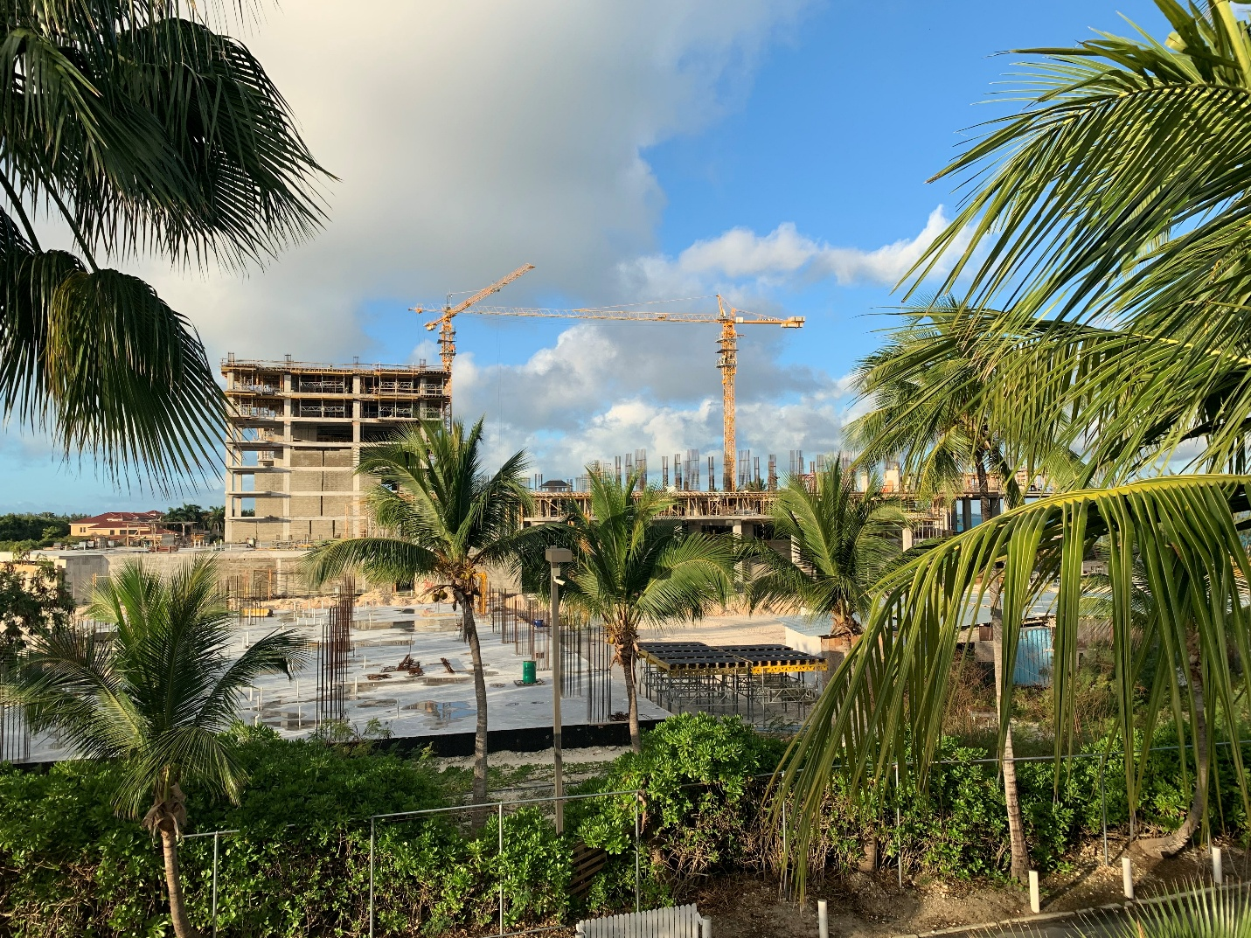
Construction on the St. Regis project next door is moving ahead quickly. The old building next to Hemingway’s was demolished during the summer, and as you can see in this picture, construction on two of the towers is well advanced.
The initial schedule was for three years of construction, but we have heard that due to strong pre-sales, the owners are trying to accelerate that pace. The project eventually will include a total of four 12-story towers, casino, restaurants, pools and other amenities.

Thus far, construction noise has not been a major issue. Even for the units closest to the construction, the noise has been far less intrusive than that of our own landscaping equipment. We will continue to monitor the situation, but for now see no need either to spend money on noise mitigation or to offer room discounts.

Housekeeping Notes

Some of the dryer ducts have become clogged, and we have decided to carry out a thorough duct cleaning every five years. This cost will be absorbed by the strata.

Owners are reminded that they are responsible for taking their own garbage to the garbage area located behind Buildings 5/6 next to the St. Regis property line.
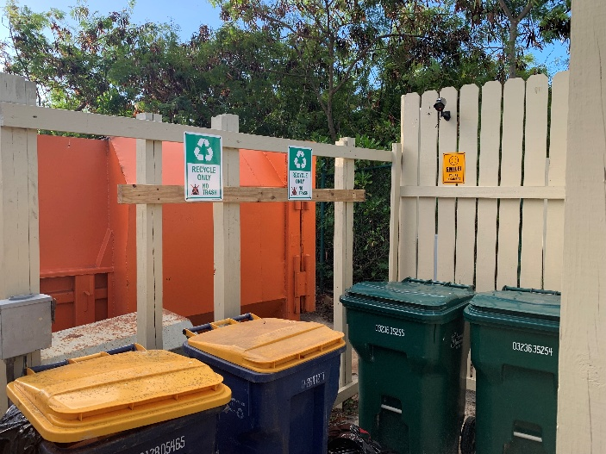
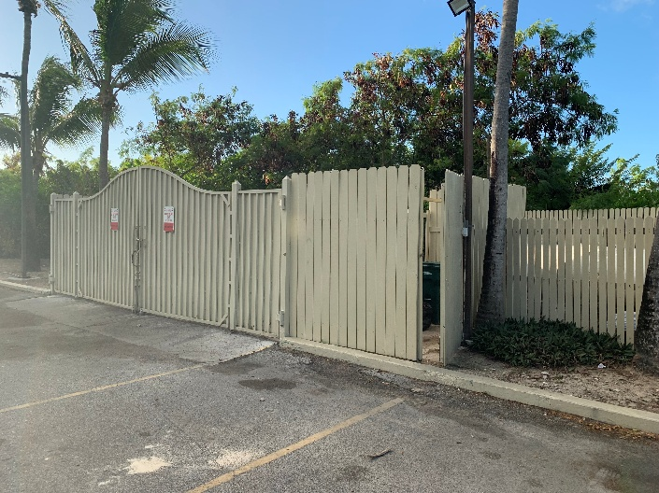

There also are recycling bins there now. Please use them. Paper, plastic, metal and glass all can be deposited together for later sorting.

Some owners have mentioned issues with unauthorized charges showing up on their statements. Mistakes happen, so please review your statements when you receive them and raise any issues with Joan Hagan.

Don’t forget that as owners, you get a 15% discount from Caicos Dream Tours if you order at the pool shack, a 10% dining discount at the Palms (where the outdoor restaurant has just completed a major renovation) and the Shore Club, and a 20% discount at the spas and retail outlets in both resorts.

Staff

We were saddened by the news that Pauline Theodore has decided to retire as our Common Area Supervisor after 26 years of dedicated service to The Sands, but wish her all the best as she moves forward.

Meeting dates

Please make sure to mark your calendars for the 2025 Annual General Meeting, which will be held on May 1 at 9:00 a.m. The Executive Committee meeting to consider the 2026 budget has been set for December 4.

Best wishes for a healthy and happy 2025!

Your Executive Committee

