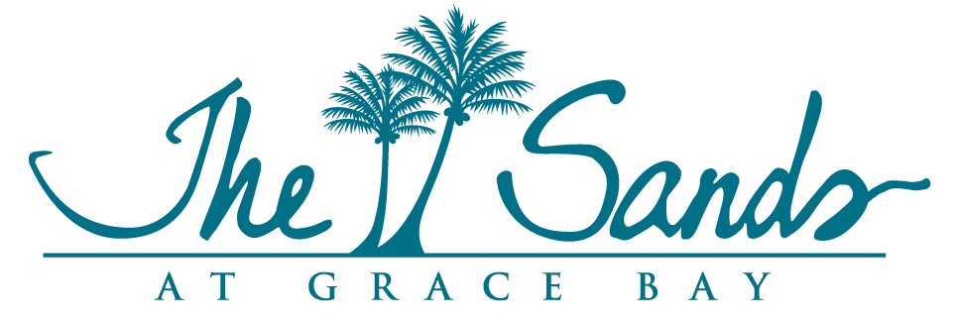

Strata Corp #25, Annual General Meeting
June 9, 2022
The Sands Hospitality Lounge

Strata Board Members Present: Strata Board Members via Zoom
Miles Hamm, Chairman David Stewart-Patterson
Stan Hartling
Tom McKewon Unit Owners via Zoom:
Tom Mothorpe Brad Groshock
Tim Lamothe
Joanne Lowre
Chris Brown
Unit Owners Present: Don Wilson
Marc Grimaud Daniel & Renee Salvato
Norman & Dolores Rogers Katie Wheler
Dan & Maureen Kelly Judy Long
Dale Brown Brian Kaminer
Jim & Corinne Labagnara Rick & Sandy Satin
Mich Landry Neil Mackintosh
Tim and Susan Lamothe Pieter de Jonge

Sands Management Team Present: Sands Management Team via Zoom:
Mona Beeson, General Manager Pierre Beswick, VP Resort Assets
Joan Hagan, Director of Owner Relations
Lincoln Martin, Financial Controller
Marc Romkey, Commercial Assets Manager
Patrick Van Hamme, CFO
Karen Whitt, VP Marketing

Miles Hamm (MH) began the meeting at 9:10am and welcomed everyone for participating in the 2022 Strata #25 Annual General Meeting and confirmed that we do in fact have a quorum of 50% of the owners either present or via Proxy is needed in order to conduct the meeting.
He then asked Stan Hartling (SH) to provide an update on the status of certain items related to the island i.e. Tax Situation, increase in crime related incidents and briefed shortly on the marketing efforts island-wide, as well as the status of the proposed St. Regis project that will be constructed just to the west of the property.
Regarding the possible Tax implications for condo owners – it has been said by Government that owners should be paying room tax on their visits. A group of Developers on island have created a fund to obtain legal counsel to defend this proposal. SH said that there hasn't been any further development in the subject and we will notify owners as soon as possible if something does arise.
Many initiatives have been put in place to reduce the amount of crime on the island and we have seen a significant decrease in these incidents.
The booking pace for the resorts has increased greatly and the support on the island is very strong. One of the contributing factors to this is that the only requirement to enter the island now is that you have to be fully vaccinated against Covid-19.
While we don’t have any definitive information on the progress or details of the proposed St. Regis project, it seems it will be proceeding. The same firm has also purchased the former Dellis Cay project. In any event, this project should have a very positive impact on our resort being next to this type of resort.

Review of Financial Statements 2021
Tom Mothorpe (TM) reviewed the Year End 2021 Financial Statements, which included the Balance Sheet, Financial Statements, Statement of Equity and CAPEX.

Review of Financial Statements YTD 2022
He then reviewed the same statements for YTD as of April 30th, 2022. SH explained the major variance for the Insurance expense is due to the fact that the insurers required a reassessment of the value of the property due to its age and replacement costs.
CAPEX
Some of the works to be completed during the September 2022 closure are as follows: resurfacing of the Hemmingway’s pool; repair of the elevator in Building 3; replacing the old ceramic tile in 15 units (the remaining 16 will be completed next year), replacement of 8 of the unit front doors that are in terrible condition, some screens and frames as needed, some of the maids’ closet doors. It was also added that the roofs were replaced in 2017 and have a 30-year warranty.

Any Other Business:
The question of better watering of the grounds arose especially since it seems to happen in prime times like mid-morning and just prior to dinnertime. PB has been looking at remote systems that could be programmed around midnight for example, but these systems can prove to be ineffective as they can be watering areas of the grounds that do not necessarily need the constant watering, thus wasting water for other areas that need it more heavily.
Outside Individuals using our facilities – with the many “off-beach” resorts coming on-line, in addition to those already in the area, there is concern that this issue will increase. The resort has looked at many different solutions and our security has to continue very diligent in this respect.
Increase in feral dogs on the property – this is an ongoing issue and the resort has been very vocal with the local authorities, the owners of the resort coming next door, etc. They have boarded up holes by the fences where they have burrowed through and are doing everything possible to mitigate the issue. It is very strongly encouraged that owners do not try to feed or give them water which only encourages their presence.

VRBO update – new forms and procedures for owners and owners’ guests and referrals has been put in place since the By-law change and we have made great progress.

Room Renovation:
While not a true Strata related topic, the proposed upcoming room renovation in September 2023 was discussed. A committee will be formed and will include the Strata Board members. There are many, many comments from the guests and travel professionals that the resort is tired and is need of renovation. SH stated that this project should be very well balanced as to what needs to be completed. This will include the guest feedback, owner’s input as well as what the Management Company sees as needed. There will be an outside interior design firm contracted to complete the finalized scope. A questionnaire will be sent to the owners asking for their input on the items they feel are most important. JH to send to the committee a brief history of previous works as well.
Another topic that was discussed was the television system in the units and the IT team is working with the local provider to obtain a better service for our guests.

Election of the Strata Board:
Linda Harper had resigned her position on the Strata Board several months ago and Tom McKewon (TK) has been appointed in her place. Since no other owners had put their names forward the existing Board remains in place including MH as Chairman.
The 2022 Strata #25 Annual General Meeting formally adjourned at 11am.

