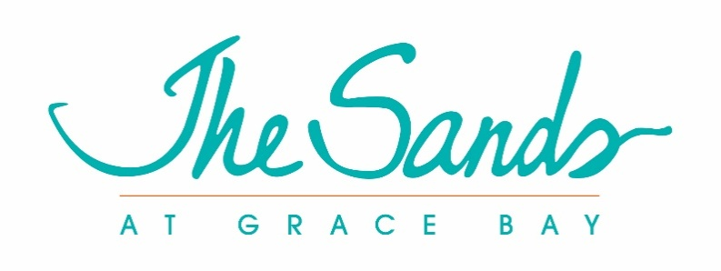
Proprietors Strata Plan #25
Strata Board Meeting
December 10, 2020 at 9:00am
December 21, 2020 at 10:00 am
Hartling Group Corporate Office and Zoom

Board Members in Attendance:
Miles Hamm, Chairman
Tom Mothorpe
Stan Hartling
Board Members via Zoom:
Linda Harper
David Stewart – Patterson

Key members of the Management team are requested to attend the board meetings to provide answers to questions that might arise in a timely manner and to provide supporting documents.
Management in Attendance:
Patrick Van Hamme, CFO
Mona Beeson, General Manager
Joan Hagan, Director of Owner Relations
Ben Hartling
Lincoln Martin, Financial Controller
Marc Romkey, Commercial Asset Manager
Pierre Beswick, VP of Resort Assets
Opening of Strata Lot #25 December Board Meeting
Miles Hamm, board chair, called the meeting to order at 9:10 and thanked everyone for joining.
Approval of the minutes of 2020 Annual General Meeting
Linda Harper made a motion to approve the minutes as edited and Tom Mothorpe seconded the motion. A show of hands was requested and the motion was approved unanimously.
Review of 2020 Financial Statements and 2021 Budget
The board reviewed the current financial statements in depth with questions regarding variance and timing of expenditures. The initial review was as of October 31; however, it was decided that the board should review the November financials first to obtain a more complete understanding of current and future financials. To accomplish this goal it was decided that another meeting would be necessary and a meeting was set for December 21.
The board also requested a discussion with management about projections for the resort for 2021 so as to have a better understanding of potential revenues that impact the 2021 budget.
At the December 21, 2020 portion of the board meeting, the discussion continued with the following determinations:
- The board will be notified when any Strata Item exceeds the budget amount by 10%.
- The board will be notified if a Capex item exceeds $5000 above the budgeted amount.
- Management agreed to waive the allowed increase in the Strata Lot Fee for 2021.
- Treasurer, Tom Mothorpe, will work with the Financial Controller, Lincoln Martin, to assure that the listings from the Major Capex account are classified correctly.
- The current 30% reduction in assessment fees will continue for the first quarter of 2021. This reduction is likely to create a deficit in the 2021 operating budget. The board will meet again in early March to review the impact of Covid-19 on the resort financially and determine the impact on the 2021 budget.
- Based on the above discussion and financial analysis, the board approved a limited Capex budget for 2021 to include three major items: replacing the main pool deck with the same wood as used at the Shore Club adult pool, replacing 15 deteriorated doors and frames, and repairing the entire 3rd floor exterior landing of Building 3.
- The initial work to repair the Water Main leaks due to increased water pressure appears to be successful. As a result, it was decided to continue to monitor the project and defer the remaining work, moving it to the 2022 Capex Reserve Budget.

Other Business
The board discussed the following topics with appropriate decisions and timelines.
- There will be a new feature to the owner’s website which will include an open forum for discussion and dialogue. Joan Hagan, Director of Owner’s Relations, was charged with the project implementation. She will work with the IT staff to create this feature. Individual board members will assume responsibility for checking the site regularly and responding to owner’s inquiries and comments.
- Regarding the posting of board minutes for this meeting and all future meetings, the board, by consensus, agreed that Linda Harper would review and edit the minutes and that the minutes would be posted to the owner’s website by the 10th of the month following the board meetings.
- All Strata board members will sign a confidentiality agreement as drafted and copies will be retained with related board documents.
- Patrick Van Hamme, CFO, reported to the board that management is working with 4 insurance firms to obtain the best price for the Property and Liability Insurance renewal for 2021. Due to worldwide disasters, he reported that there is a possibility that insurance rates might increase as much as 20%. He will keep the board posted as negotiations continue.
- Board member and liaison to the Strata Management Agreement Committee, David Stewart Patterson, reported on the status of the review and revisions to a Strata Management Agreement. The board offered several suggestions which will be taken back to the committee for further discussion. The board plans to review the committee’s recommendations in the first quarter of 2021.
- The board set the date for the Annual General Meeting for June 17, 2021.

The board meeting of Strata Lot #25 was adjourned by Miles Hamm, the board chair.

