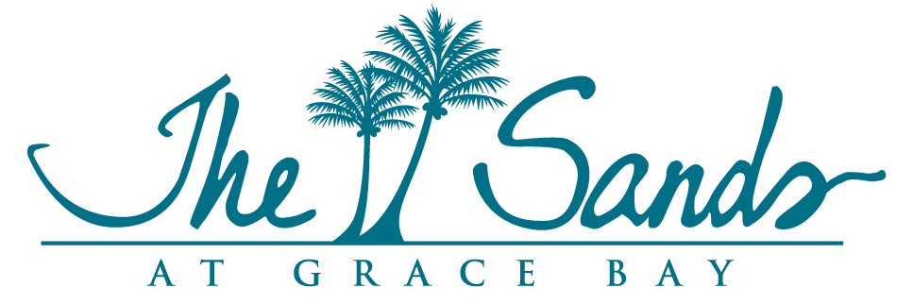

Strata Corp #25
The Sands at Grace Bay
Annual General Meeting
June 11, 2020
Via Zoom

Strata Board:
Miles Hamm, Chairman
Stan Hartling
Dolores Rogers
Linda Harper, via Zoom
Tom Mothorpe, via Zoom

Management:
Mona Beeson, General Manager
Pierre Beswick, VP Resort Assets
Joan Hagan, Director of Owner Relations
Lincoln Martin, Controller
Tracy McKenzie, Corporate Financial Controller
Patrick Van Hamme, CFO
Karen Whitt, VP Marketing
Cepheus Whyte, Property Manager

Owners present:
Elisabeth Flamant, Sarah McAteer, John Galleymore (representing Kevin Cawood)
Owners via Zoom:
Brian Kaminer, John and Pam Dixon, Yvonne Mothorpe, Craig Emby, Judy Long, John Kendall, Ivan Cowger, Gayle Jinks, Pieter DeJonge, Amy Hughes, Dan and Melissa Pauli, Tim Lamothe, Brian and Alison Peck, Chris Brown, Brad Groshock, Robert Adolph, Carla Conti, Joanne Lowre, Ivan Vohlmuth, Jeff Turk, Bogden Krystek, Dale Brown, Malcolm Teasdale, Kathy Ginley, Julie Spellman, Roger Ziontz, Archie Cheng, David and Suzi Pendergast, Dan and Maureen Kelly, David Johnson, Robert Demers, Doug and Missy Cohen-Fyffe, Fred and Jamie McClain, Wes Stearns, David Stewart Patterson and Oriana Trombetti

At 9:15am, Miles Hamm (MH) opened the Meeting.

MH stated that per the Strata Ordinance, a Chairman for the meeting needs to be elected. Linda Harper (LH) made the motion to elect MH as the Chairman, Stan Hartling (SH) seconded the motion. A show of hands was requested and unanimously approved.
LH then explained the difference between what are considered Strata items and what are considered Management Company related items.
The Strata Board then introduced themselves.

Financial Reports – Tom Mothorpe (TM)
TM explained the Balance Sheet as of December 31, 2019 and March 31, 2020, as well as the Statement of Operations, Statement of Equity and Capex Summary for the periods ended December 31, 2019 and March 31, 2020 and answered any questions from owners.
TM explained Income From Utilities is the 10% administrative markup on the utility bills and that 10% goes to the Strata Corp.
SH explained that the management company also pays strata fees for the areas that the Management Company owns: Hemmingways, Lobby, Laundry Building as well as pays the same fees to the Capex the same as other owners.
MH asked JH (Joan Hagan) whether there were enough proxies submitted to establish a quorum. A quorum consists of 50% of the owners either present or via proxy and is needed in order to conduct the Meeting. This was an unusual year due to the country’s lock down and the quorum basically consisted of submitted proxies. JH confirmed that a quorum was established.
PVH stated that the Major Reserve Capex Contribution had been suspended by the Strata Board during the shutdown and they would review after when to reinstate it.

VRBO:
MH noted that the issue of short term rental via VRBO is becoming an issue on the island. Several resort have sought legal counsel and have and have passed or are considering changes to the By-Laws to address the issue. MH asked Dolores Rogers (DR) to report further on the subject. Additionally, with the current COVID-19 situation, the resorts have strict protocols for guests and staff and special preparation of the guest rooms prior to each guest arriving. This is a challenge when an owner rents his unit out separate from the management company as the same protective protocols are not followed, thus posing a potential health threat to our guests and staff.
One owner noted how a VRBO situation affected their rental. A guest who had typically always rented their specific unit when they visited, had been approached by an owner during one of their visits and was offered a lower rate if they stayed in that particular unit thus resulting in losing that regular guest and revenue.
There was a consensus that the Strata Board will create an amendment to the current By-Laws that will prevent owners from renting their units on a short-term basis without going through the Management Company.
MH stated that in order to change the By-Laws, two thirds of the owners need to approve the change. An Extraordinary General Meeting will be called and the change will be voted on then.
MH made the motion to contract legal counsel to create the proposed By-Law amendment of restricting short term rentals. TM seconded the motion. SH abstained from voting to avoid any possible conflict of interest. The two remaining Board Members agreed. Once completed, the proposed By-law change will be sent to all owners for review.
This change to the By-Laws would only apply to short term rentals. Units that are not in the rental program can rent their units on a long-term basis which is 30 days or longer.

Covid-19 Update:
SH gave an update on the Covid-19 situation on the island and the preventative measures being taken island-wide.

Audit:
The subject of an Audit of the Strata Financials had been raised. TM explained that the definition of an audit and as a Financial Accountant, feels that one is not needed. MH made the motion that an audit would not be carried out and LH seconded the motion. A show of hands was requested and unanimously agreed.

Strata Works presentation:
MB presented to the owners all of the Strata Works that had been carried out throughout the resort during the shutdown.

Election of the Strata Board:
There were 6 candidates who put their names forward for the 5 openings for the Strata Board. They were, Miles Hamm, Linda Harper, Stan Hartling, Tom Mothorpe, Dolores Rogers, David Stewart Patterson. Due to Covid-19, almost all of the voting was done via Proxy. A representative of Twa, Marcelin and Wolf, The Sands Legal Counsel, was asked to attend the Meeting and verify the validity of each proxy submitted and tabulate the votes. Since this process took some time to accomplish, the meeting was adjourned and Karen Whitt, VP of Marketing was asked to provide a report on her marketing efforts for the Sands.
The Strata Meeting was then called back to order by the Chairman to announce the results of the election. The Strata Corp #25 Board Members are Miles Hamm, Linda Harper, Stan Hartling, Tom Mothorpe and David Stewart-Patterson (DSP). MH thanked Dolores Rogers for her years as Strata Chairperson and Board Member.

Strata Management Contract:
MH stated that the Strata Management Contract will be up for renewal in 3 years. He asked DSP to lead a committee for the suggested amendments for the Contract that will be consolidated and presented to the Board for review and consideration. SH will not be part of this process and will wait for the final suggestions to be presented to him by the remaining members of the Board. MH asked for those owners who wish to be a part of this committee to put forward their names and bios to DSP.

The Strata Corp #25 officially adjourned at 1:16pm.

