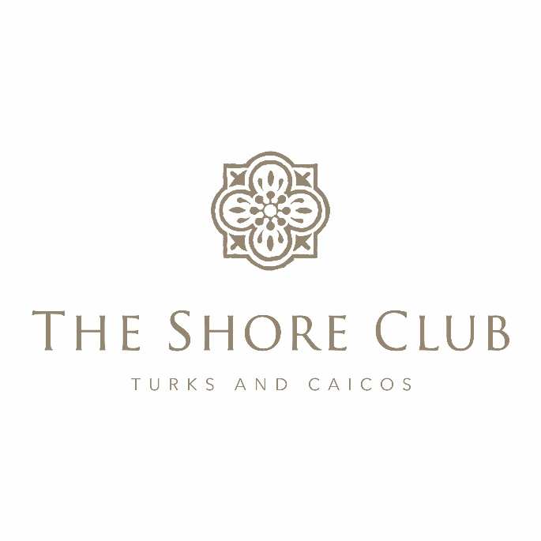
Strata Corp #125
Annual General Meeting
May 8, 2026
The Shore Club

Strata Board in attendance:
Charles Dickson
Stan Hartling
Strata Board in attendance via Zoom:
David Holdsworth
Don Fewer
Bill O’Brien

Management:
Pierre Beswick, VP Resort Assets
Chris Elliot, General Manager
Joan Hagan, Director of Owner Relations
Ben Hartling, Special Projects Manager
Lyra MacFarlane, Financial Controller
Iain McCormack, VP of Operations
Marc Romkey, Corporate Asset Manager
Patrick Van Hamme, CFO
Karen Whitt, VP Sales and Marketing
Raymond Yip, Revenue Manager

Owners Present:
Gary Usling
Karen and Frank Kuspza
Andy and Jeanne Anderson
Owners Present Via Zoom:
David and Suzie Pendergast, Dan DiPrete, Gorr Sahakian, Gregs Thomopolous, michael and Monica Richardson, Bill and Rosemary Kehren, Mike and Mary Krensavage, Larry Shaia, Bruce McNicol, Bruce Munro

At 10:03am, Charles Dickson (CD) began the Strata #125 Annual General Meeting and established that the quorum needed for the meeting had been met.

Review of Financial Statements Year To Date:
Lyra MacFarlane (LM) presented the Strata #125 2025 Strata Financials.
After the review of the financials and any questions answered, Stan Hartling (SH) made the motion to approve the 2025 Strata Financials.
LM then presented the 2026 year to date Financials and Pierre Beswick explained the CAPEX year to date and projections.

It was then asked of the owner group if there were any new Strata related items to discuss to which there were not, so at 10:41am, CD made the motion to adjourn the Strata #125 Annual General Meeting and SH seconded the motion.

