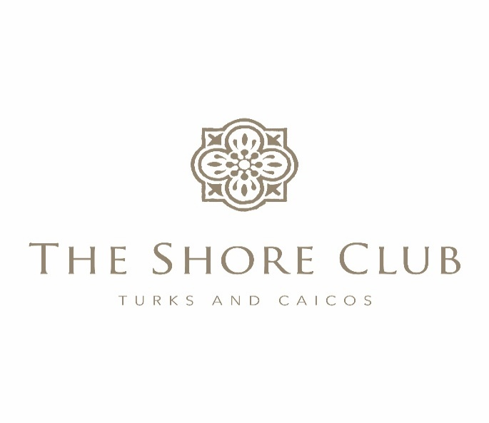
Strata Corp #125
Annual General Meeting
May 8, 2025
Strata Board in attendance: Owners in Attendance:
Charles Dickson, Chairman Frank Kuszpa and Karen Paolella
Stan Hartling, Board Member Keith and Lenore Charette
David Holdsworth, Board Member Andy and Jeanne Anderson
Management: Bruce MacNicol
Pierre Beswick, VP Resort Assets Lane and Lauren Rosen
Joan Hagan, Director of Owner Relations Normande Lapointe
Lyra McFarlane, Financial Controller Owners in Attendance Via Zoom
Iain MacCormack, VP of Operations Bill O’Brian, Board Member
Patrick Van Hamme, CFO Don Fewer, Board Member
Karen Whitt, VP Sales and Marketing Lawrence Shaia
Raymond Yip, Revenue Manager Monica Richardson Gregs Thomopolous
Bruce Munro
Nancy Jourdan
Karen Fix
Tim and Jan McConville
Siran Sahakian
Charles Dickson, Board Member, began the Annual General Meeting and welcomed all and thanked all for attending.
Charles Dickson (CD) asked Joan Hagan (JH) to verify if we had a quorum, to which she confirmed we did.

Review of Financial Statements Year To Date:
Lyra McFarlane (LM) explained the 2024 Financial Statements.
Pierre Beswick (PB) explained the 2024 Capex Reports.
He then further explained the 2024 Major Capex.
They then explained the 2025 Financial Statements to date.
No other questions were presented.
PB explained the Capex and Major Capex. The resort will be closing from 8/24-10/4 to redo the roofing of the buildings.
He was then asked to look at the Colonnade pool surface as the bottom is rather rough and perhaps this could be addressed at the same time.
With no further questions, CD made the motion to approve the 2024 Financial Statements, and DH seconded the motion.

Seagrapes Enhancement Presentation:
SH showed the plans to enhance the Seagrapes Restaurant area and adjacent dune area. There was strong owner support to expand and improve the areas around Seagrapes and dune area.
It was also noted that the beach bar is in disarray and should be renovated/replaced. SH will meet with those owners on island Friday to review the areas and show the proposed plans for all the areas.
Strata Board Election:
Since there were not any owners that wished to be considered for the Strata Corp Board, the existing Board was re-elected.
SH made the motion to adjourn The Strata Corp #125 Annual General Meeting, and CD seconded the motion.

