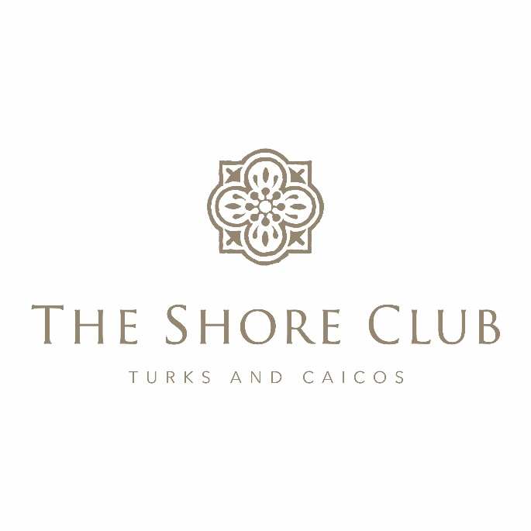
Strata Corp #125
Annual General Meeting
May 10, 2024

Strata Board in attendance: Owners in Attendance:
Charles Dickson, Chairman Frank Kuszpa and Karen Paolella
Stan Hartling, Board Member Keith Charette
Bill O’Brien, Board Member Owners in Attendance Via Zoom
Management: Andy and Jeanne Anderson
Pierre Beswick, VP Resort Assets Lawrence Shaia
Patrick Van Hamme, CFO Meichelle O’Brien
Karen Whitt, VP Sales and Marketing Bruce Munro
Naji Esta, Hotel Manager Monica Richard
Joan Hagan, Director of Owner Relations Gregs Thomopolous
Lyra McFarland, Financial Controller, via Zoom Ron Moskovitz
Nancy Jourdan
Dan DiPrete
Blair McDaniel

Charles Dickson, Board Member began the Annual General Meeting and welcomed all for attending.
Charles Dickson (CD) asked Joan Hagan (JH) to verify if we had a quorum, to which she confirmed we did. A Chairman for the Meeting has to be appointed, at which time Stan Hartling (SH) made the motion to appoint CD as Chairman for the meeting and Bill O’Brien (BO) seconded the motion.

Review of Financial Statements Year To Date:
Lyra McFarland (LM) explained the 2023 Financial Statements.
Pierre Beswick (PB) explained the 2022 Capex Reports.
He then further explained the 2022 Major Capex.
Frank Kuspka inquired as to what the difference between the Capex and Major Capex funds are to which PB explained that the Capex is for items that have a longevity of approximately 2-5 years and Major is for items that have a longevity of about 5+ years. We will be contracting BCQS to do a study of the Strata Plan areas to ensure there are sufficient funds in the Major Reserve.
They then explained the 2024 Financial Statements to date.
BO inquired about the Sand expense and why it was different last year vs this year. SH explained that last year, the company that it was procured from had just dredged the Leeward channel and because there was such an abundance of it, they were able to cost much less.
No other questions were presented.

Water Safety Update:
Naji Esta (NE) provided an update on the ongoing measures of both the resort and the government (DECR) to make sure that the swim areas are as safe as possible for our guests. He stated that when there is a situation, the camera footage is given to the DECR and they address the situation. They have even confiscated jet skis from providers that do not have proper insurance, etc.

Strata Board Election:
After the tally of the ballots and those assigned to proxies, the existing Strata Board remains in place.
SH made the motion to adjourn The Strata Corp #125 Annual General Meeting and CD seconded the motion.

