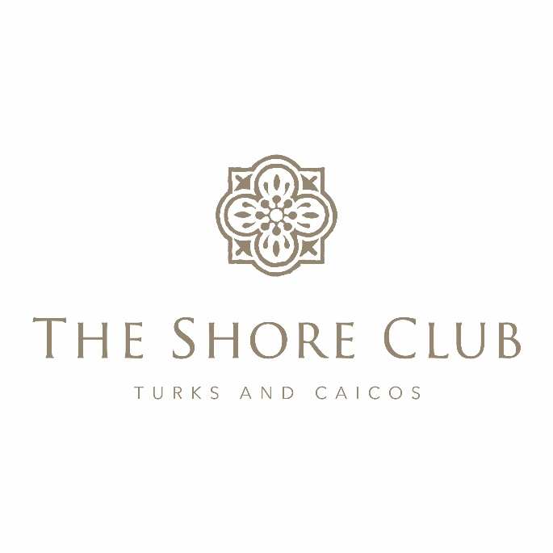
Strata Corp #125
Annual General Meeting
May 16, 2023

Strata Board in attendance: Owners in Attendance:
Charles Dickson, Chairman Tim and Jan McConville
Stan Hartling, Board Member Frank Kuszpa and Karen Paolella
Jim Stanton, Board Member Bruce and Cindy MacNicol
Strata Board in attendance via Zoom: Kelli Stanton
Christian DeGrace David Holdsworth
Andy and Jeanne Anderson
Management: Owners in Attendance Via Zoom
Pierre Beswick, VP Resort Assets Lawrence Shaia
Patrick Van Hamme, CFO Bill O’Brien
Karen Whitt, VP Sales and Marketing Christian DeGrace
Naji Esta, Hotel Manager Karen Fix
Joan Hagan, Director of Owner Relations Ashley Mehta
Lyra McFarland, Financial Controller, via Zoom Ron Moskovitz

At 9:07am, Charles Dickson, Strata #125 Chairman, began the Annual General Meeting.
Stan Hartling (SH) asked Joan Hagan (JH) to verify if we had a quorum, to which she confirmed we did.
He then presented what he calls the Three Buckets which explains the differences between what areas are considered to be Strata, Management Company, and those that are “co-mingled”.

Review of Financial Statements Year To Date:
Lyra McFarland (LM) explained the 2022 Financial Statements.
Pierre Beswick (PB) explained the 2022 Capex Reports. The overages were primarily due to pumps, supplies and the cost increase.
He then further explained the 2022 Major Capex.
They then explained the 2023 Financial Statements to date.
No questions were presented.

Insurance:
SH explained the increase in insurance and thanked Patrick Van Hamme (PVH) for all of his hard work in obtaining excellent coverage for the property/owners while some resorts saw extremely high increases in coverage rates.

Water Safety Update:
Naji Esta (NE) provided an update on the ongoing measures of both the resort and the government (DECR) to make sure that the swim areas are as safe as possible for our guests. SH also encouraged the owners that should they witness someone acting in an unsafe manner, to let someone in management know as soon as possible, so they can review the camera footage and proceed accordingly.

Strata Board Election:
Since Mitch Zajac had informed that he wished to step down as his unit had sold, there was one position available. It was announced after the instructed Proxies were tabulated that David Holdsworth would be the newest Strata Board Member.
Even though Mitch was not on the Zoom, SH thanked him for his years of valuable service on the board, and also thanked Andy Anderson and Bill O’Brien for putting their names forward and interest in participating on the Board.
The Strata Corp #125 Annual General Meeting officially concluded at 10:53am.

