As you know, I wrote ACID TRIP: Travels in the World of Vinegar, but you might not know I’ve been writing for Vinegar Professor, leading up to our USI Vinegar Competition!

We’re about ready to receive our first entries as the website is almost done — but in the meantime, I’m looking for judges to do tasting panels.

Here’s the info:
- We plan to ship out blind samples the week of March 18th or 25th, then you’d have a week to taste — we can discuss the process.
- Each judge will get a discount code to share with their producers.
- $250 stipend to judge … via PayPal, Venmo, check, etc.

If you’re interested, I’d need the following from you:
- A headshot
- A brief bio (e.g. how long in industry, how much vinegar from how many producers you buy in a year, why interested in vinegar/judging …)

Let’s talk acidity!

Hope you’re well.

GREG DUNMORE, The Japanese Pantry, San Francisco

Greg is an accomplished San Francisco chef with twenty-five plus years of experience. Throughout his career he has run critically acclaimed restaurants and earned Michelin Stars. Greg’s passion for Japanese food came early on and was most visible in his last venture as chef/owner of Nojo, a San Francisco top 100 restaurant, where he created his own unique Japanese-inspired California Izakaya. Over the years of traveling to Japan Greg forged relationships with artisanal producers and is excited to help them bring their products to the US.

As a co-founder of The Japanese Pantry, we have imported 3 different vinegar producers and currently we import two producers. Iio-Jozo is our main company that we work with and we bring in currently 7 different types from them every 2 to 3 months.

greg dunmore
co-founder
the japanese pantry
2565 third street, suite 233
san francisco, ca 94107 usa
main: +1.415.767.5251
direct: +1.415.767.5253
fax: +1.415.223.3454
www.thejapanesepantry.com

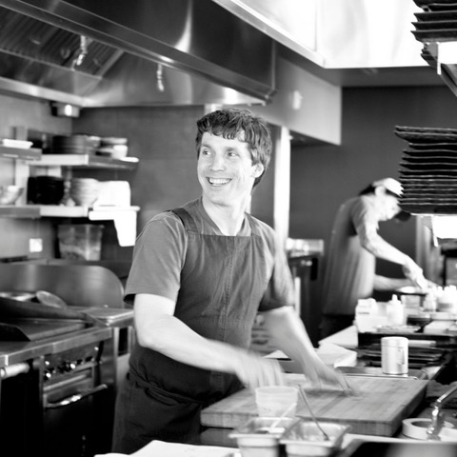

TENAYA WILLETTE-GREEN, Bi-Rite Market, San Francisco

Tenaya Willette-Green
Market Inventory Control Manager
Bi-Rite Divisadero
Tenaya@biritemarket.com

KYLE HUGHES, Faire, San Francisco/NYC

Kyle helps lead the Food & Beverage brand partnerships team at Faire. He grew up in Northern California and has spent the majority of his career working in food. He graduated from New York University and shortly thereafter moved back to San Francisco and immersed himself in the local food movement. He’s previously led wholesale programs at 4505 Meats, Black Oak Coffee Roasters and Bellwether Coffee, and co-founded a Food & Beverage consulting company to advise emerging brands on growing their businesses. He’s also worked at numerous restaurants throughout the region including the Delfina Restaurant Group.

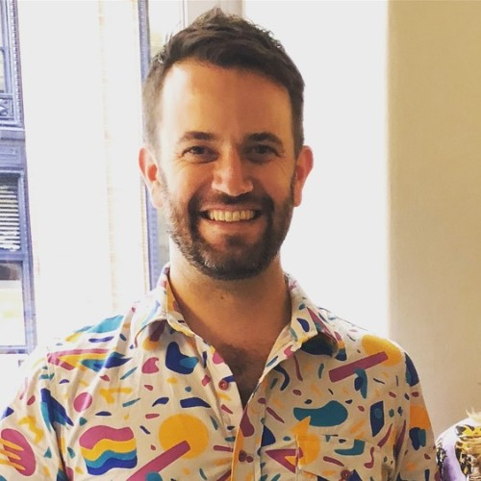

GRACE SINGLETON, Zingerman’s, Ann Arbor, Michigan

Grace Singleton
Managing Partner
Zingerman's Delicatessen
422 Detroit St.
Ann Arbor MI 48104
located in the Kerrytown District
deli- 734 663 3354
mobile- 734 904 4068

JULIA HALLMAN, Formaggio Kitchen, Cambridge, Massachussets and NYC

Julia Hallman is the owner of Formaggio Kitchen, a small chain of award-winning specialty food shops located in the Boston area. She's been in the industry for over 16 years and during that time she has had the pleasure of tasting hundreds of vinegars. Formaggio Kitchen's flagship store located in Cambridge, MA has over 80 different vinegars at any given time, ranging from Balsamico Tradizionale di Reggio-Emilia and Balsamico di Modena to fresh takes from iconic American producers like American Vinegar Works and Katz.

via
Elizabeth Moroney She/her/hers
General Manager
Formaggio Kitchen Cambridge
358 Huron Ave
Cambridge, MA 02138
Tel: +1.617.354.4750
www.formaggiokitchen.com

Morgan Mannino
Media Manager
She/Her/Hers
Formaggio Kitchen
358 Huron Avenue
Cambridge, MA 02138
t: +1.617.354.4750 x1005

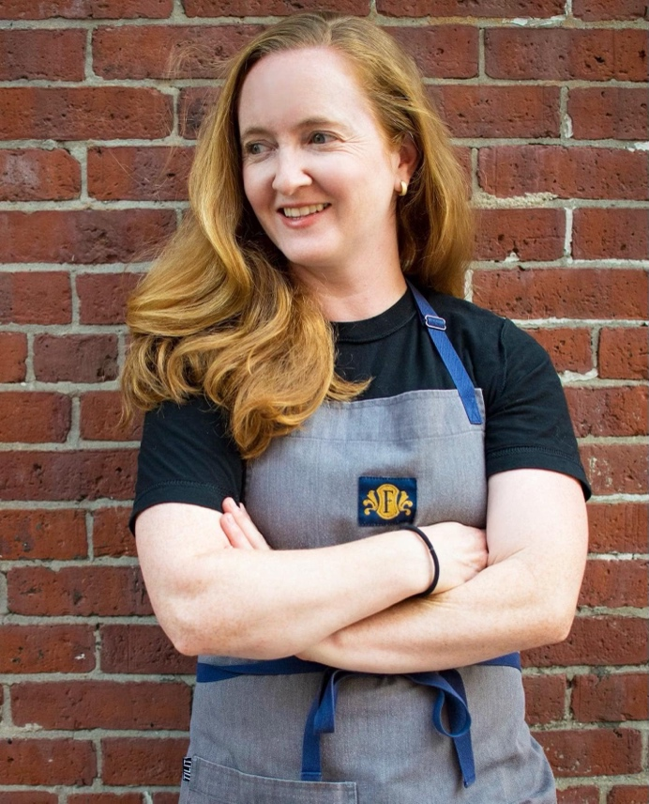

JIM DIXON, Wellspent Market, Portland, OR

BIG NIGHT, Brooklyn, NYC
Katherine Lewin and/or Stacey Mei Yan Fong

STEPH STEELE, Tiny Grocer, Austin, Texas

Steph Steele
Owner|Operator|Grocer
510.541.5871 (m)

TINYGrocer SoCo
1718 So. Congress
Austin TX 78704
512.520.5735 (G)

TINYGrocer Hyde Park
4300 Speedway, Suite 101
Austin TX 78751
512.375.3320 (G)

MICHAEL HARLAN TURKELL, Vice Principal, Vinegar Professor

Michael Harlan Turkell, a once aspiring chef, now photographer, author, and podcaster, has twice been nominated for James Beard Foundation awards, photographed dozens of cookbooks, and written a few, including his own, "ACID TRIP: Travels in the World of Vinegar", which won an IACP award for culinary travel writing. He's hosted long-running podcasts for Heritage Radio Network, Food52 and Modernist Cuisine, and teaches food photography at New York University. Turkell lives in Brooklyn, NY, and is still in search of the premier malt vinegar for his fries.

